Secure Networks With Firewalls NAT, Port filtering, packet filtering, and other method

Q1. Set up Windows Defender Firewall on your Windows laptop or PC and create a new inbound rule to block all incoming traffic on port 8080. Take a screenshot of the rule you created.
Ans:
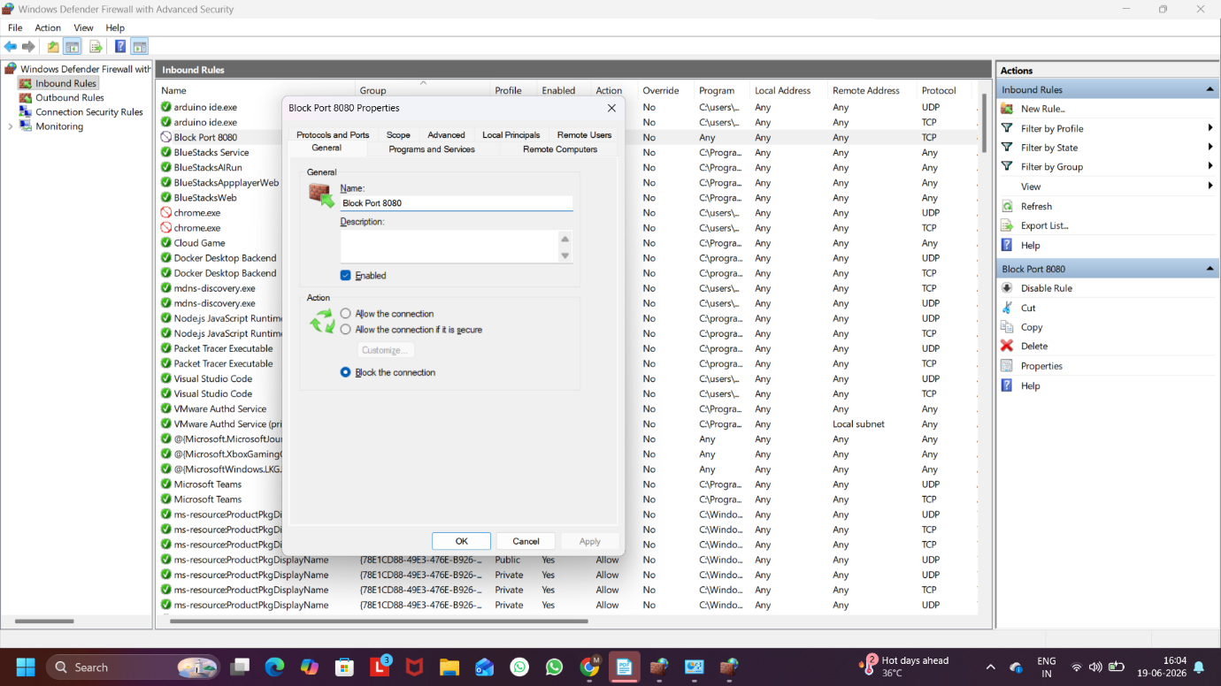
Figure 1: Windows Defender Firewall Rule Blocking Port 8080

Q2. Simulate NAT (Network Address Translation) by drawing a simple diagram showing how your home WiFi router assigns private IP addresses to your phone, laptop, and smart TV, and how it translates them to a single public IP for internet access.<br><br><em><strong>Hint:</strong> Use any drawing tool or even hand-draw and click a photo.</em>
Ans:
Explanation:
Network Address Translation (NAT) is a technique used by routers to allow multiple devices with private IP addresses to share a single public IP address when accessing the internet. The router translates the private IP addresses of the devices into one public IP address before sending data to the internet and translates the responses back to the correct device.
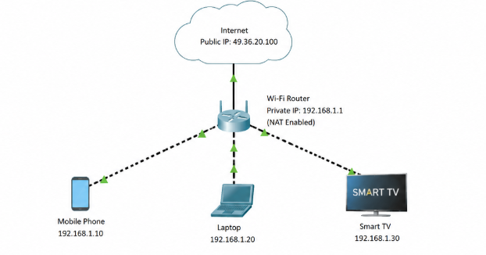

Figure 2: NAT Translation in a Home Wi-Fi Network

Q3. Configure port filtering using your WiFi router's admin panel (or use a router simulator online if you don't have access). Block outgoing traffic on port 25 (SMTP) and explain in 2 sentences how this could help prevent spam from your network.
Ans:
Steps to Configure Port Filtering (Block Outgoing SMTP Port 25)
- Open a web browser and enter the router's IP address (usually 192.168.1.1 or 192.168.0.1).
- Log in to the router using the administrator username and password.
- Navigate to Security, Firewall, or Access Control settings.
- Open the Port Filtering or Outbound Filtering section.
- Click Add New Rule.
- Set the following values:
  - Rule Name: Block SMTP
  - Protocol: TCP
  - Port Number: 25
  - Direction: Outbound
  - Action: Block / Deny
- Save the rule.
- Apply the configuration and restart the router if required.
Explanation
- Blocking outgoing traffic on port 25 (SMTP) helps prevent infected devices from sending spam emails directly to external mail servers.
- This reduces the risk of the network being used for spam distribution and improves overall network security.

Q4. Given a sample packet filtering rule set (provided by your trainer), identify which of these three sample packets would be allowed or blocked: 1) HTTP request from 192.168.1.5 to 172.217.166.78:80, 2) SSH request from 10.0.0.10 to 34.201.23.1:22, 3) DNS query from 192.168.1.7 to 8.8.8.8:53.<br><br><em><strong>Hint:</strong> Focus on source/destination IPs and ports in the rule set.</em>
Ans:
Condition:
Port 80 incoming block
Port 22 incoming block

Packet | Status | Reason
1. HTTP request from 192.168.1.5 to 172.217.166.78:80 | Allowed | This is an outgoing HTTP request. The firewall rule blocks only incoming traffic on port 80.
2. SSH request from 10.0.0.10 to 34.201.23.1:22 | Allowed | This is an outgoing SSH request. The firewall rule blocks only incoming traffic on port 22.
3. DNS query from 192.168.1.7 to 8.8.8.8:53 | Allowed | This is an outgoing DNS request using port 53, which is not blocked by the firewall rules.

Q5. Research and list 3 ways Instagram or Zomato might use firewalls and packet filtering to protect their servers from attacks or misuse.
Ans:
Three Ways Instagram and Zomato Use Firewalls and Packet Filtering:
1. Blocking Unauthorized Access
- Firewalls allow only authorized users and services to access servers.
- Suspicious or unauthorized connection requests are automatically blocked.
2. Protection Against DDoS Attacks
- Packet filtering helps identify and block large volumes of malicious traffic.
- This prevents attackers from overwhelming servers and disrupting services.
3. Filtering Malicious Requests
- Firewalls inspect incoming network packets and block harmful requests.
- This helps protect user accounts, personal information, and application servers from cyberattacks.
Conclusion:
Instagram and Zomato use firewalls and packet filtering to secure their networks, prevent unauthorized access, and protect their servers from malicious traffic and cyber threats.

